6A^{th} Grade: Unit 10, Lesson 5
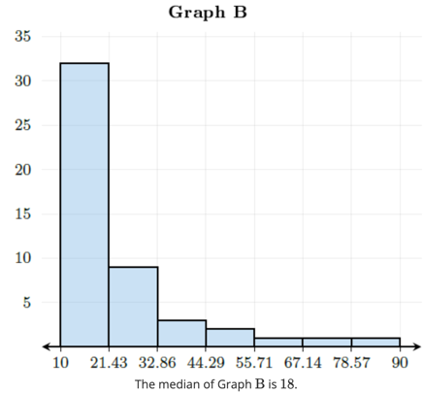
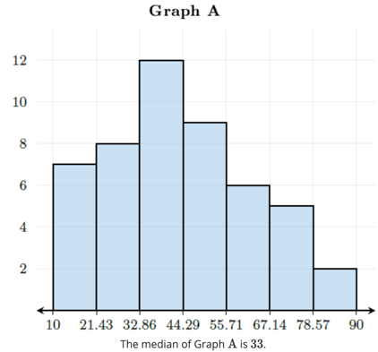

- Given two data displays, which data set will have a larger median?

Graph A
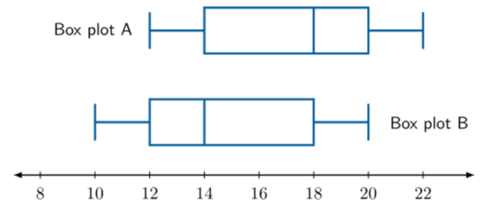

- What is the median of box plot A?

18

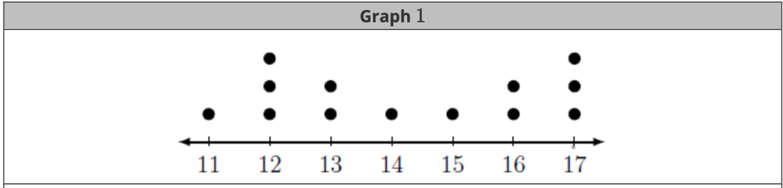
- What is the mean of the dot plot given?

14.23

